2017 RACE TO RENEW- Save My Seats

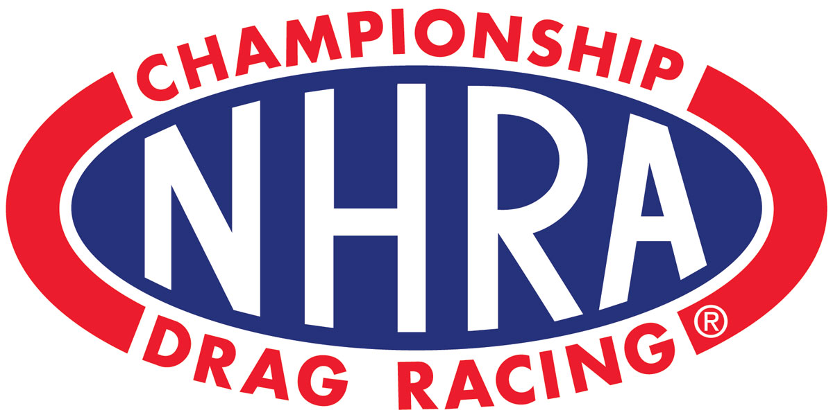

**Celebrating 20 Years of SPEED**

It’s OFFICIAL! Castrol Raceway has partnered with the National Hot Rod Association to bring you the best Drag Racing North America has to offer- The ***Rocky Mountain Nationals featuring the NHRA Canadian Open***. Join us for our 20th Anniversary Season and 15th Rocky Mountain Nationals event for the best Nitro Charged professional Drag Racing along with North Americas most hardcore Class Competition.

**The Rocky Mountain Nationals featuring NHRA Canadian Open**

**July 14-16, 2016.**

**Just in time for the Holidays- Give the Gift of Speed**

RACE TO RENEW YOUR TICKET ORDER TODAY

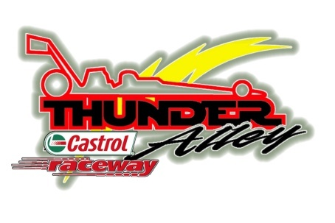***The Ultimate Upgrade: Thunder Alley***

**Back with More fun, more food, and more incredible VIP entertainment- the Thunder Alley VIP Weekend Experience!** The All inclusive Event Experience: Members only hospitality lounge access, premium weekend seating, hot catered meals, unlimited beverages, exclusive gifts, private bar service, preferred parking, private autograph sessions, and much more.

QUICK & EASY: SAVE YOUR SEAT ONLINE

**RENEW BY PHONE/Seat Upgrade**

Contact the Castrol Raceway office directly at anytime (780) 461-5801, to renew your order over the phone or If you would like to upgrade your seats. You must contact the Castrol Raceway office to do so before the December 15, 2016 cutoff date. All upgrades will be processed on a first come-first serve basis.

Thank you for choosing Castrol Raceway as your Place to Play, we look forward to sharing an exciting 20th Anniversary Season with you.

Our kindest regards,

***Rob & Kimberly Reeves***

**Castrol Raceway**

Your Personal On-Line Order Renewal Code

**Jeff Hedrick**  
**Order Number: 13551804**